EASTERN INTERNATIONAL UNIVERSITY  SCHOOL OF COMPUTING AND INFORMATION TECHNOLOGY | Practice Assignment – Quarter …, 20…-20…  Course Name: Special Topic 1  Course Code: CSE 484  Student’s Full Name: Hà Quang Minh  Student ID: 1931220012
Lab 8

Background
Using Netmiko, Paramiko, RESTCONF/NETCONF, Ansible, and Nornir for CSR1000v Only
In this lab you will:
- Apply a basic security baseline on a CSR1000v router
- Monitor CPU and memory usage
- Use multiple automation tools and frameworks:
  - Netmiko
  - Paramiko
  - RESTCONF / NETCONF (ncclient)
  - Ansible
  - Nornir
This lab demonstrates how the same operational data can be accessed from CLI, SSH libraries, APIs, and automation frameworks.

Requirements
- CSR1000v with:
  - SSH enabled
  - NETCONF enabled
  - RESTCONF enabled
- PC with:
  - Python 3.9+
  - Libraries:
netmiko, paramiko, requests, ncclient, nornir, nornir-netmiko, nornir-utils
  - Ansible + cisco.ios collection
- CSR1000v credentials (privilege 15)

3-Hour Lab Structure
Part | Topic | Time
1 | Security baseline + verification | 30 minutes
2 | CPU/Memory monitoring via Netmiko & Paramiko | 40 minutes
3 | CPU/Memory monitoring via API (RESTCONF/NETCONF) | 40 minutes
4 | CPU/Memory checks via Ansible & Nornir | 70 minutes

Part 1 – Security Baseline via CLI & Netmiko (30 minutes)

1.1 Apply Security Baseline via CLI
Configure on CSR1000v:
username cisco privilege 15 secret cisco
ip domain-name lab.local
crypto key generate rsa modulus 2048
ip ssh version 2
line vty 0 4
login local
transport input ssh
service timestamps log datetime msec
logging buffered 20000
banner motd #AUTHORIZED USERS ONLY#
Deliverables
- Screenshot showing:
  - show run | include username
  - show run | include ip ssh
  - show run | include logging buffered
  - show run | include banner

1.2 Security Verification via Netmiko
Write a Python script to:
- Connect to CSR1000v
- Run:
  - show running-config | include username
  - show running-config | include ip ssh
  - show line vty 0 4 or show login
- Print a report indicating:
  - SSH enabled (yes/no)
  - Local user exists (yes/no)
  - MOTD banner configured (yes/no)
Deliverables
- Netmiko security check script
- Output screenshot
My Solution
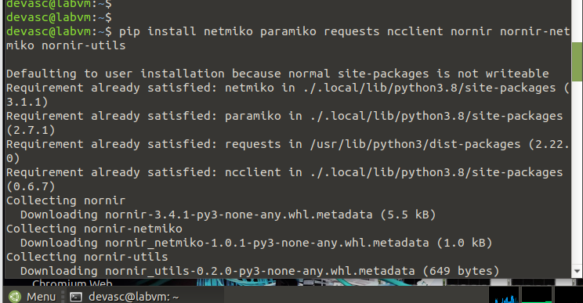
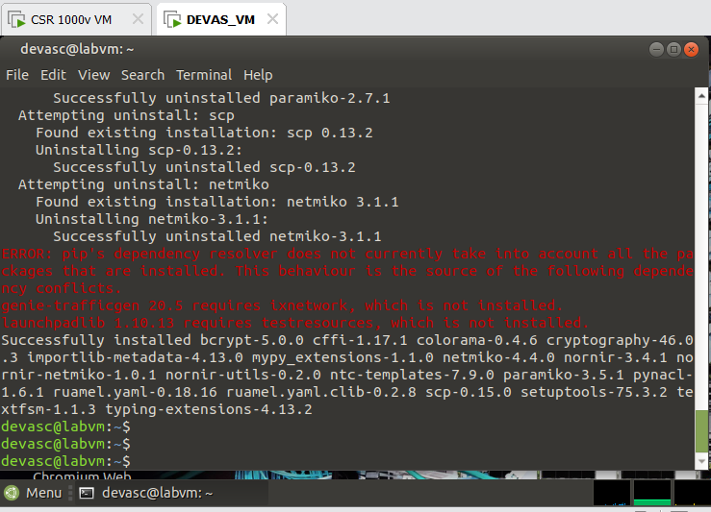
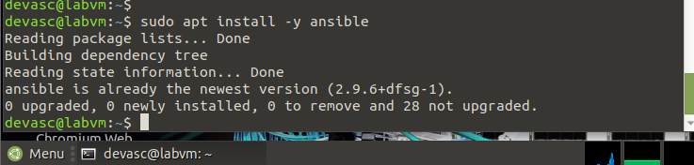
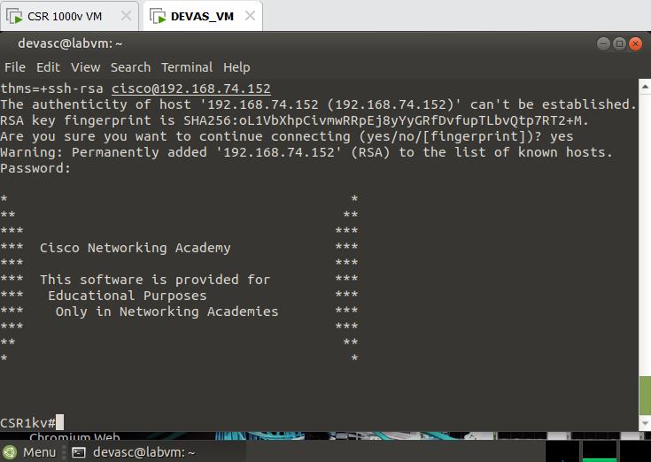

Using : ssh -oKexAlgorithms=+diffie-hellman-group14-sha1 -oHostKeyAlgorithms=+ssh-rsa cisco@192.168.74.152
Delete the old key : ssh-keygen -R 192.168.74.152

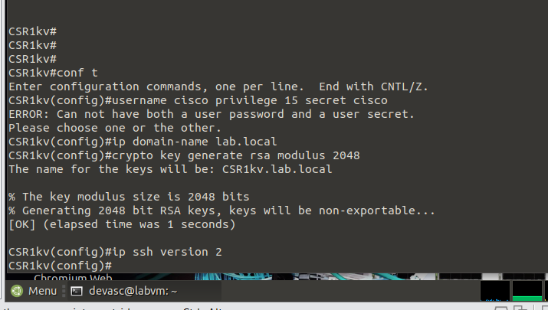
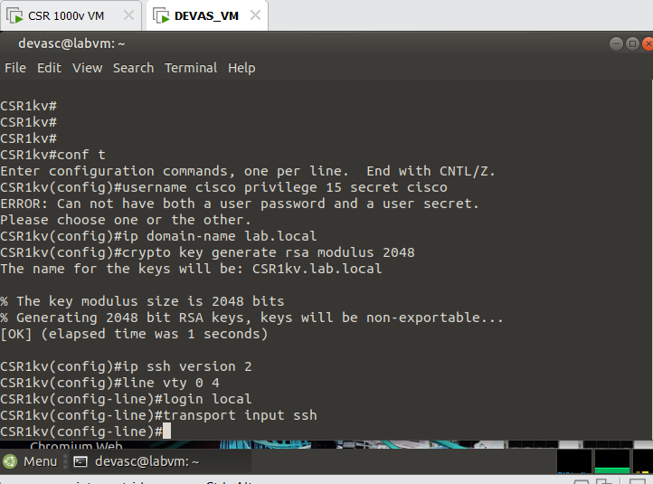

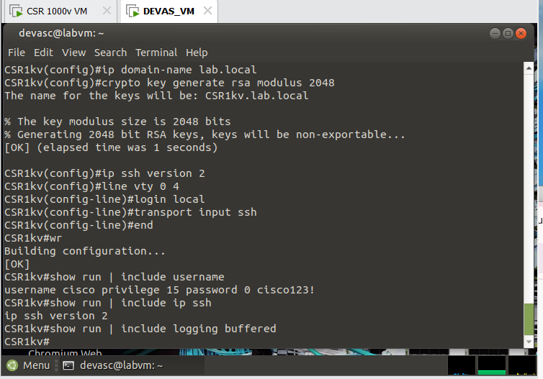
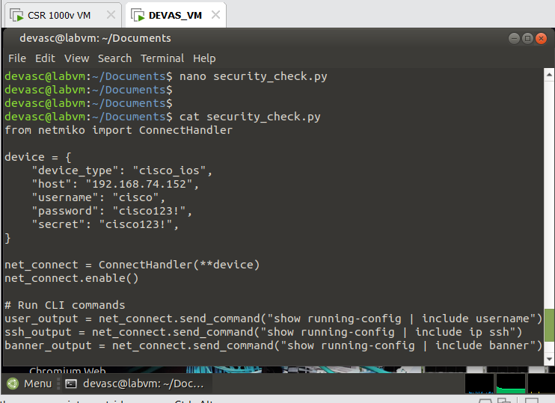
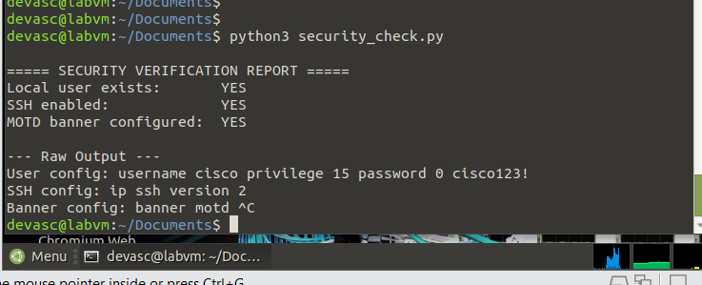

Part 2 – CPU/Memory Monitoring via Netmiko & Paramiko (40 minutes)

2.1 CPU/Memory via Netmiko
Write a script using Netmiko:
- Connect to CSR1000v
- Run:
  - show processes cpu sorted | include one minute
  - show processes memory | include Processor
- Parse and print:
  - CPU 1-minute usage
  - Memory used vs free
Deliverables
- cpu_mem_netmiko.py
- Output screenshot

2.2 CPU/Memory via Paramiko
Using Paramiko:
- Connect to CSR1000v
- Run a single multi-command block: show processes cpu sorted | include one minute show memory statistics
- Print the output
- Compare with Netmiko results
Deliverables
- cpu_mem_paramiko.py
- Output screenshot
My Solution
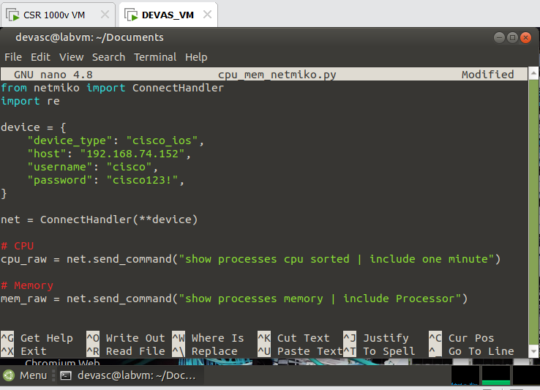
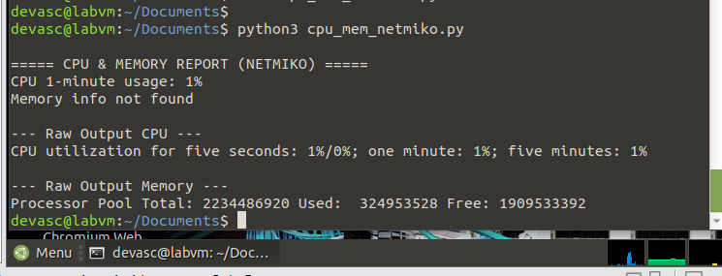

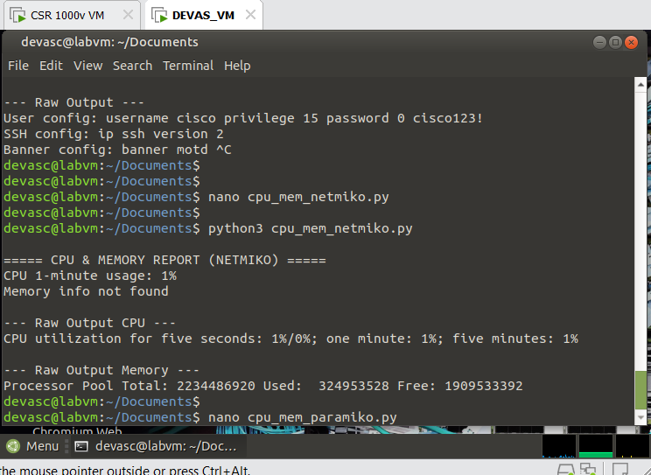
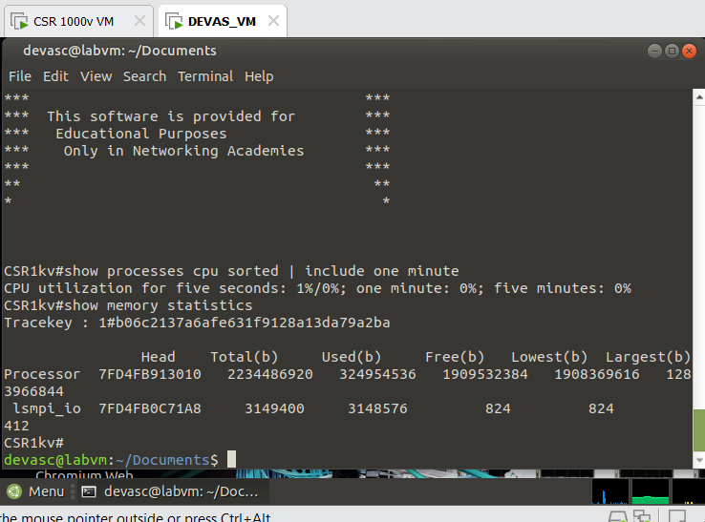

Part 3 – CPU/Memory Monitoring via RESTCONF or NETCONF (40 minutes)
Choose RESTCONF or NETCONF, or complete both if time permits.

3.1 CPU/Memory via RESTCONF
- Use Python requests
- Query a YANG path for operational data (e.g., interface stats or system stats)
- Save output as: restconf_cpu_mem.json
Note:
Some IOS-XE images may not expose CPU/memory YANG models. If unavailable, use interface counters as activity indicators.

3.2 CPU/Memory via NETCONF (ncclient)
- Connect to port 830
- Create a <get> filter for system/process/interface stats
- Save NETCONF XML reply: netconf_cpu_mem.xml
Deliverables
- RESTCONF or NETCONF script
- JSON/XML output file
- Short note if CPU/memory YANG models unavailable
My Solution
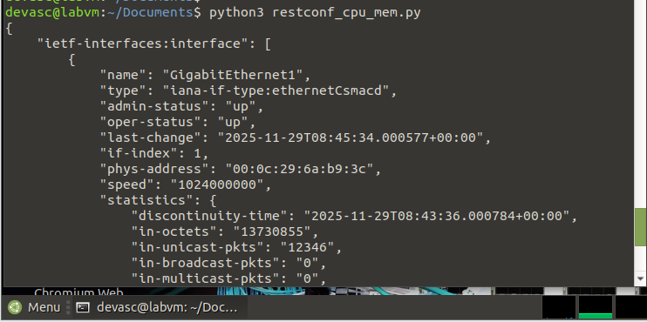

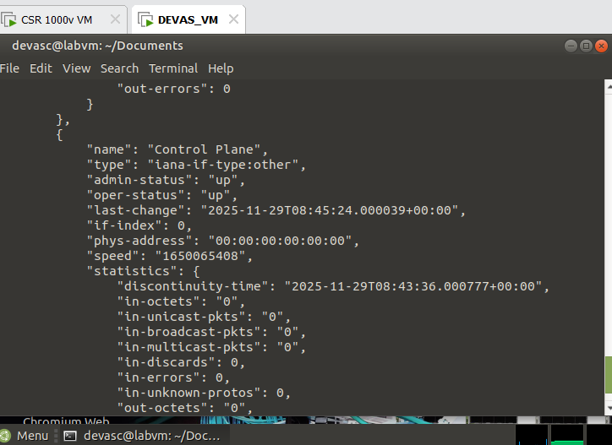
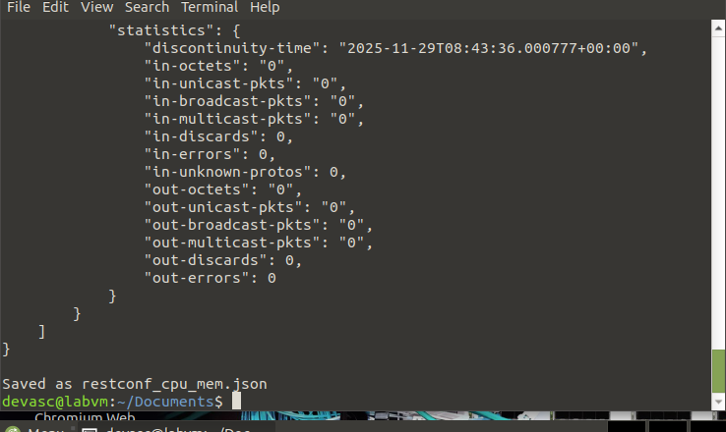
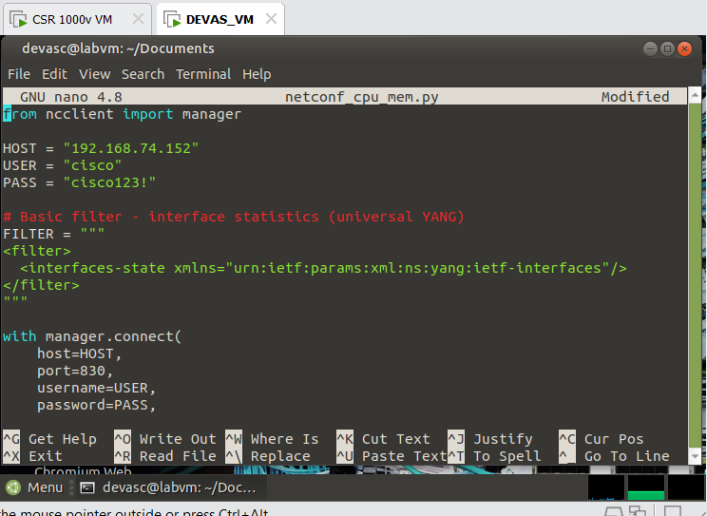
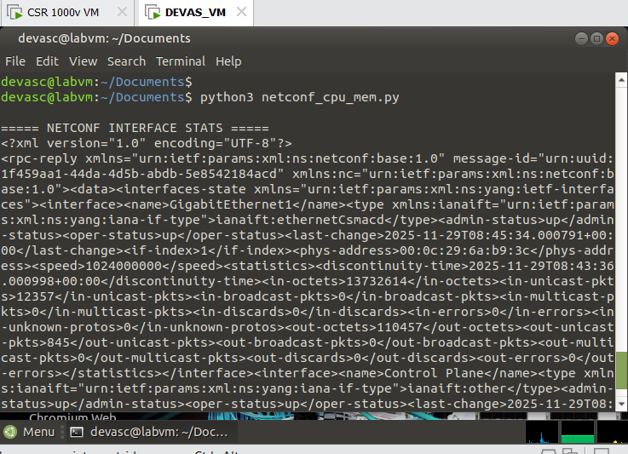
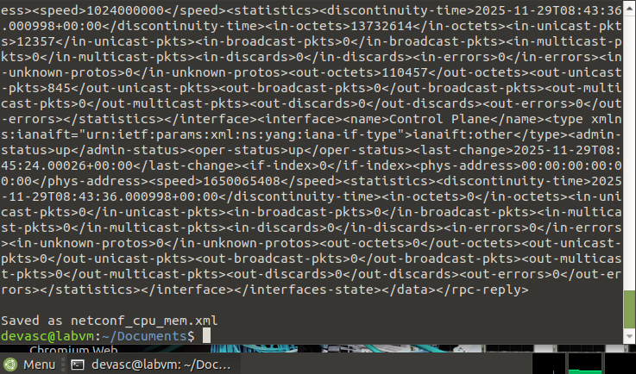
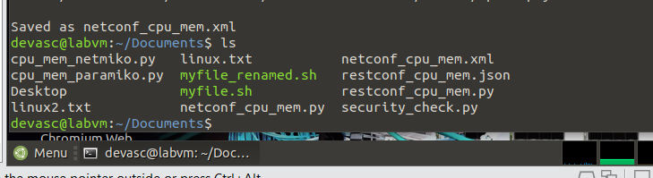

Part 4 – CPU/Memory Checks via Ansible & Nornir (70 minutes)

4.1 Ansible — Security + CPU Snapshot

Inventory (hosts)
- [csr] csr1 ansible_host=192.168.2.50

Variables (host_vars/csr1.yml) must include:
- ansible_user
- ansible_password
- ansible_network_os
- ansible_connection
- ansible_become
- ansible_become_method
- ansible_become_password

Playbook (security_cpu_check.yml) should:
- Collect device facts
- Run:
  - show login or show line vty 0 4
  - show processes cpu sorted | include one minute
  - show processes memory | include Processor
- Write all output to: artifacts/csr1_security_cpu_mem.txt
Deliverables
- Hosts
- host_vars
- playbook
- output file in artifacts/
My Solution
- 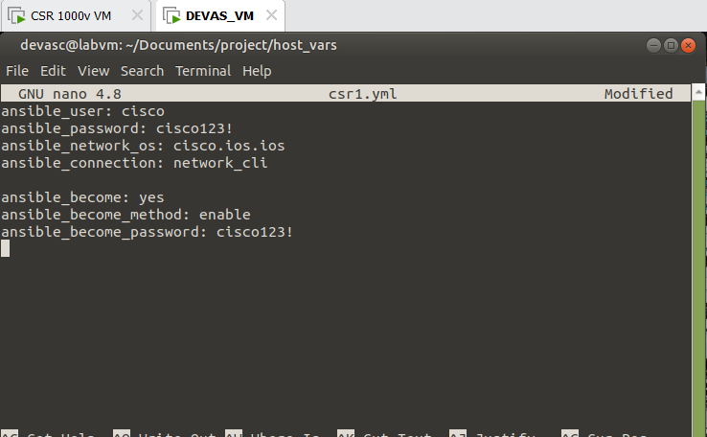

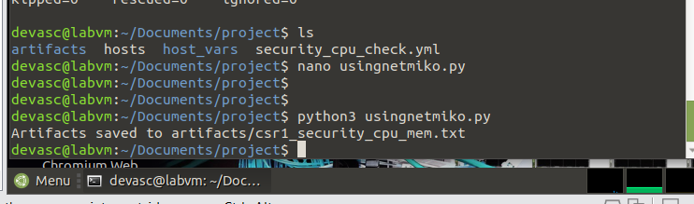
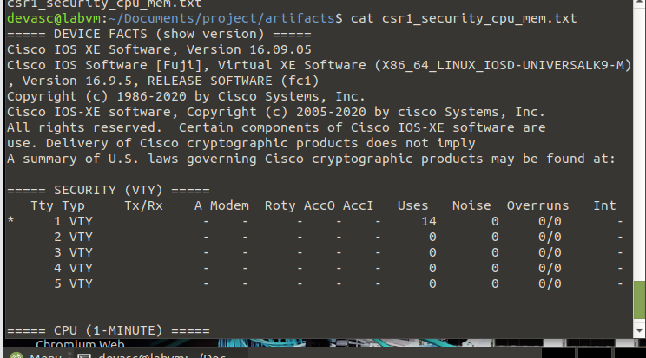

4.2 Nornir — Simple Interface/CPU Poll

Required Files
- config.yaml
- hosts.yaml
- groups.yaml

Nornir Script Requirements
Your script must:
- Load Nornir
- Execute:
  - show interfaces description
  - show processes cpu sorted | include one minute
- Print results using print_result()
- Write a summary file: nornir_cpu_summary.txt containing:
  - hostname
  - CPU 1-minute usage
  - number of interfaces up/up
Deliverables
- Nornir inventory files
- Nornir script
- Summary file
My Solution
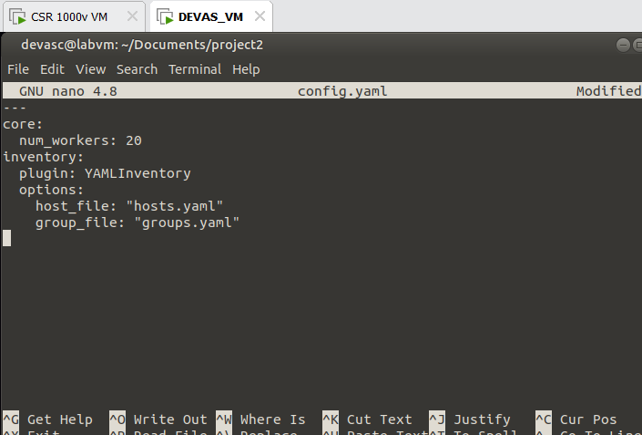

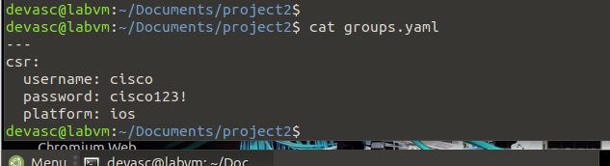
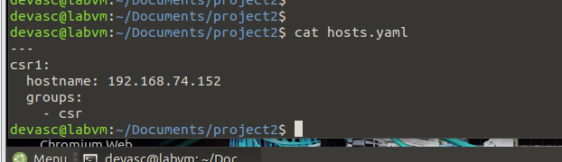
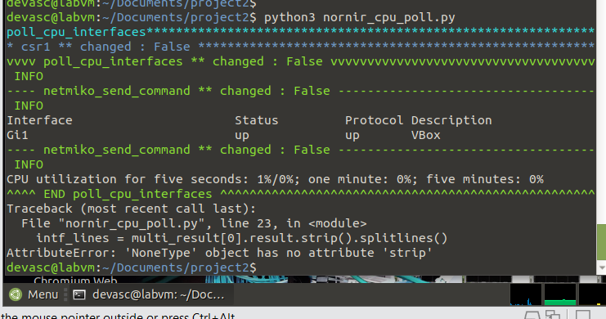
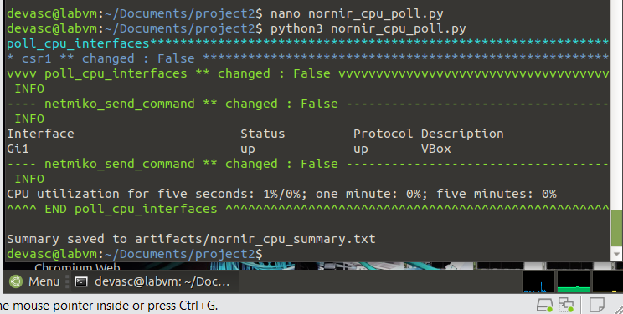
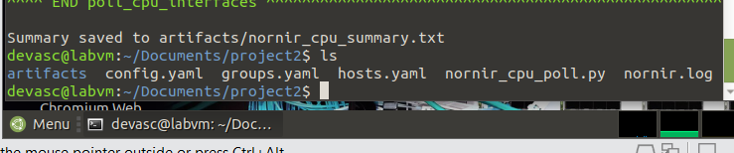s

Submission: Must include:
- a pdf report file containing your information (student id, name), and images of the diagrams, codes, answers, evident,…
- and all source code files (if any)
in a zipped (.zip or *.rar) file to Moodle

